**PRACTICAL: 7**

**Create a working prototype using the prototyping tool Figma.**

**What is Prototyping?**

Prototyping in UI/UX design refers to the process of creating a preliminary model or draft of a digital product to test and evaluate its functionality, design, and user experience before the final product is developed. Prototyping is an essential step in the design process, allowing designers and stakeholders to visualize and interact with the proposed design, gather feedback, and make informed decisions.

Here are key aspects of prototyping in UI/UX design:

1. **Visualization:** Prototypes provide a tangible representation of the design, allowing designers to visualize the layout, navigation, and overall structure of the interface. This helps in understanding how the final product will look and feel.
2. **User Interaction:** Interactive prototypes allow designers to simulate user interactions with the product. This includes clicking buttons, navigating between screens, and experiencing basic functionality. It helps designers and stakeholders understand the flow and usability of the interface.
3. **User Feedback:** Prototypes are used to gather feedback from users, clients, and other stakeholders. This feedback is crucial for identifying potential issues, refining the design, and ensuring that the final product meets user needs and expectations.
4. **Iterative Design:** Prototyping supports an iterative design process, where designers can make quick changes and improvements based on feedback. This iterative approach helps in refining the design and addressing issues early in the development process.
5. **Communication Tool:** Prototypes serve as a communication tool between designers, developers, and stakeholders. They provide a common understanding of the design direction, reducing the likelihood of misunderstandings and misinterpretations.
6. **Time and Cost Savings:** Identifying and addressing design flaws during the prototyping stage can save time and resources compared to making changes after the development of the final product has begun.

Prototyping in UI/UX design using Figma involves creating interactive and clickable representations of your digital product to simulate user interactions and test the user experience. Figma is a cloud-based design tool that allows collaborative design and prototyping. Here are the steps to create a prototype in Figma:

1. **Create Artboards:** Start by designing your interface on Figma's canvas using frames or artboards. Each frame represents a screen or page in your digital product.
2. **Design Elements:** Add UI elements like buttons, text, images, and other components to your artboards to create the visual design of your interface.
3. **Organize Layers:** Keep your design organized by using Figma's layer system. Name layers appropriately and group elements to make it easier to work with.
4. **Create Interactive Elements:** Use Figma's interactive features to create clickable elements. You can turn any object into a clickable hotspot by selecting it and adding a prototype link. This is done in the Figma prototype mode.
5. **Add Interactions:** In the Figma prototype mode, you can specify interactions for each clickable element. Define what should happen when a user clicks on a button, such as navigating to another frame or showing a dropdown.
6. **Define Transitions:** Figma allows you to define transition animations between frames. You can set the type of transition (e.g., slide, dissolve) and adjust the duration to create a more realistic interactive experience.
7. **Preview the Prototype:** Use Figma's built-in preview mode to interact with and test your prototype. This allows you to experience the flow of your design as users would.
8. **Share for Feedback:** Once you are satisfied with your prototype, you can share it with stakeholders, clients, or team members for feedback. Figma provides a shareable link that allows others to view and interact with your prototype.
9. **Iterate Based on Feedback:** Collect feedback from stakeholders and users and use it to iterate on your design. Figma makes it easy to make changes and update the prototype in real-time.
10. **Handoff to Developers:** Figma also supports design-to-development handoff. Developers can inspect design elements, view specifications, and download assets directly from Figma.

Step 1: Open Figma and open your design.

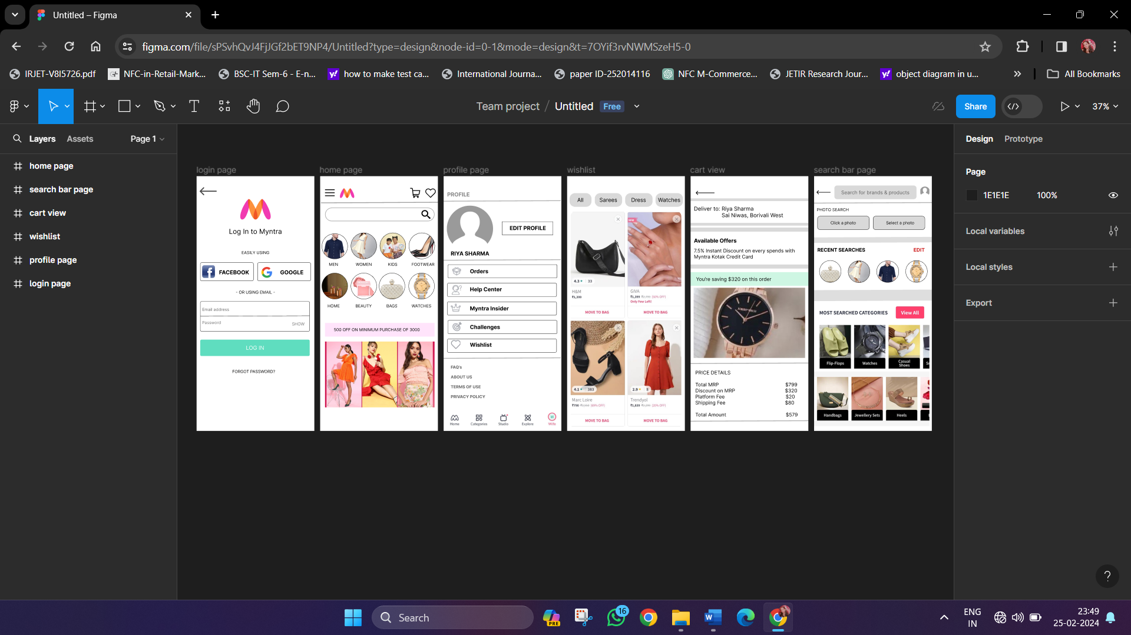

Step 2: Click on the button through which you need to navigate to another page.

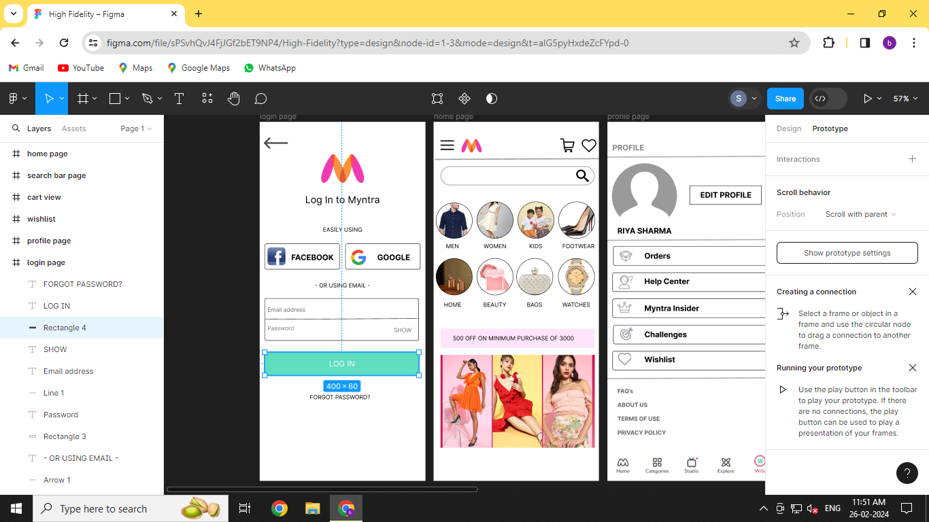

Step 3: Click on Prototype on the right corner

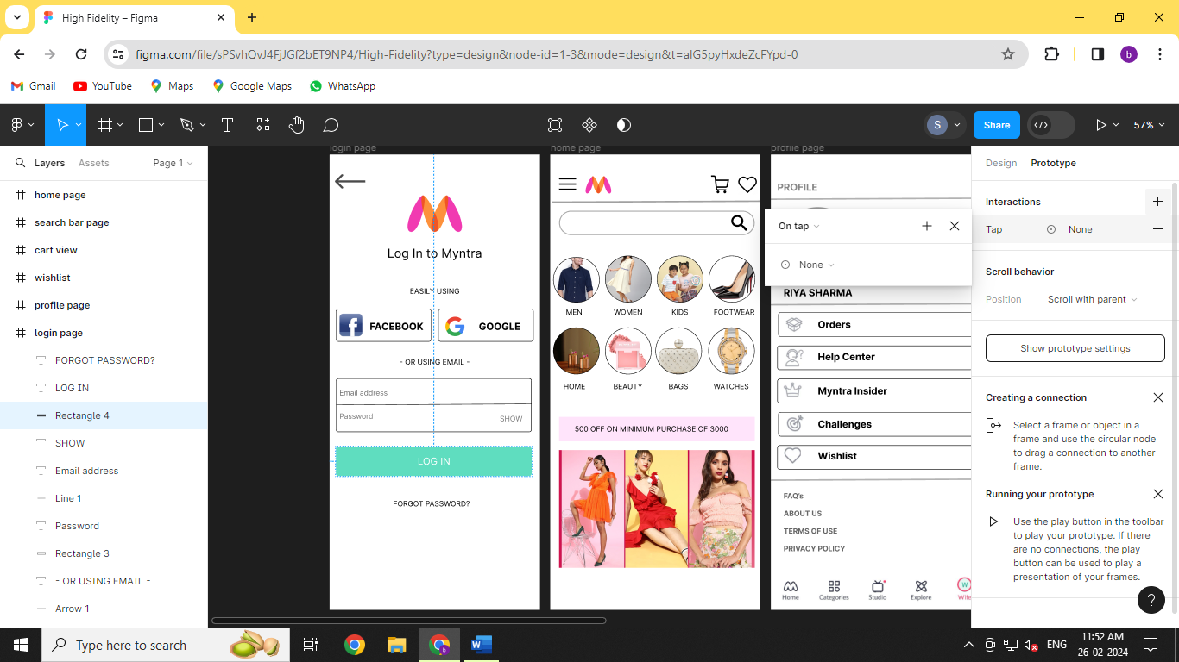

Step 4: Go to “Navigate to”

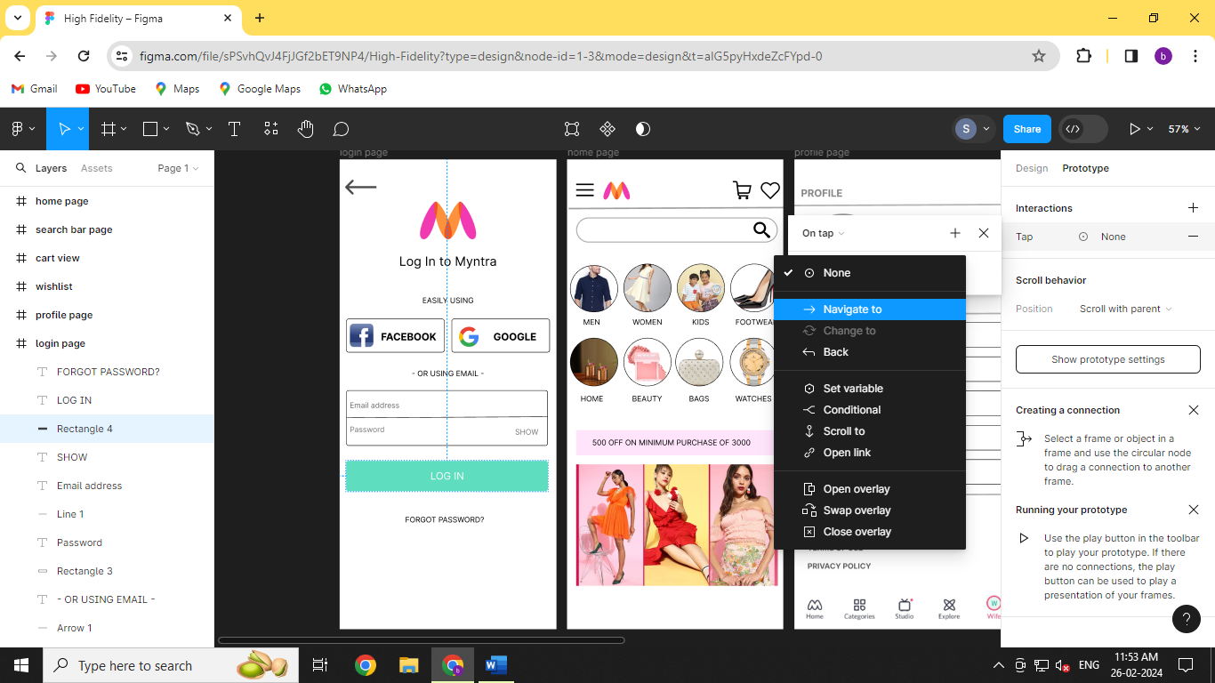

Step 5: Select the page you want to redirect to upon clicking the button.

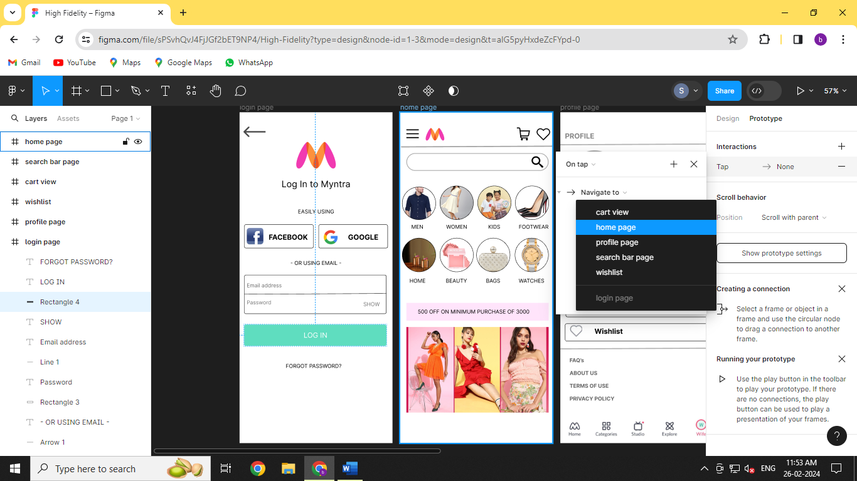

Step 6: You can see the arrow displaying the navigation between two pages, which means upon clicking on the log in button the user will be directed to the home page.

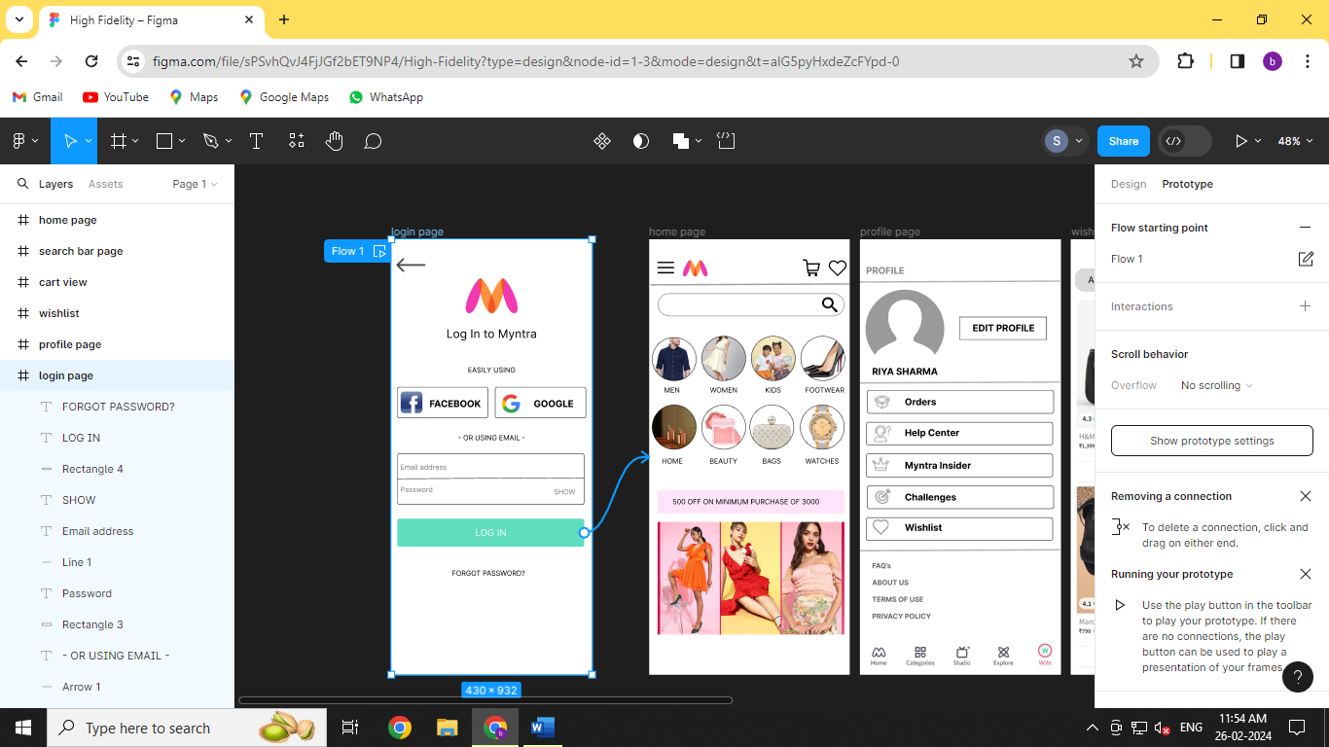

Step 7: Now preview the design and check whether the prototype of navigation is working.

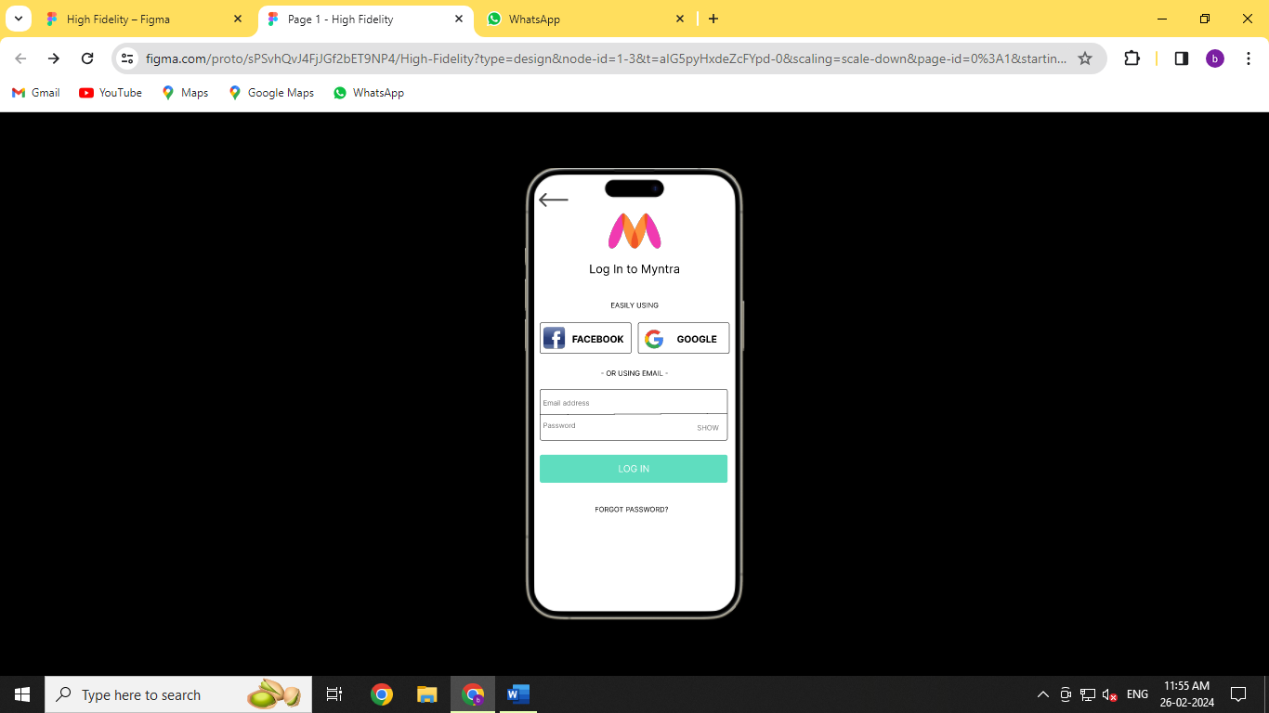 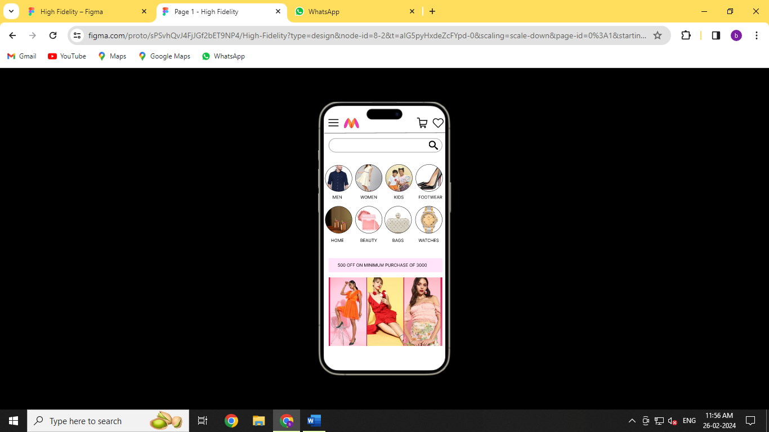

Step 8: Now connect every page to each other to create a working prototype.

